**Task 5: Write a Terraform script to provision an AKS cluster with Azure Monitor enabled.**

**Output**: aks-terraform-script.tf, output logs of resource deployment.

* **aks-terraform-script.tf**

provider "azurerm" {

features {}

subscription_id = "<azure-subscription-id>"

}

resource "azurerm_resource_group" "aks-mahesh_rg" {

name = "aks-mahesh-resource-group"

location = "Central US"

}

resource "azurerm_virtual_network" "aks-mahesh_vnet" {

name = "aks-mahesh-vnet"

location = azurerm_resource_group.aks-mahesh_rg.location

resource_group_name = azurerm_resource_group.aks-mahesh_rg.name

address_space = ["10.1.0.0/16"]

}

resource "azurerm_subnet" "aks-mahesh_subnet" {

name = "aks-mahesh-subnet"

resource_group_name = azurerm_resource_group.aks-mahesh_rg.name

virtual_network_name = azurerm_virtual_network.aks-mahesh_vnet.name

address_prefixes = ["10.1.1.0/24"]

}

resource "azurerm_log_analytics_workspace" "aks-mahesh_logs" {

name = "aks-mahesh-log-workspace"

location = azurerm_resource_group.aks-mahesh_rg.location

resource_group_name = azurerm_resource_group.aks-mahesh_rg.name

sku = "PerGB2018"

retention_in_days = 30

}

resource "azurerm_kubernetes_cluster" "aks-mahesh" {

name = "aks-mahesh-cluster"

location = azurerm_resource_group.aks-mahesh_rg.location

resource_group_name = azurerm_resource_group.aks-mahesh_rg.name

dns_prefix = "aks-maheshdns"

default_node_pool {

name = "default"

node_count = 2

vm_size = "Standard_DS2_v2"

vnet_subnet_id = azurerm_subnet.aks-mahesh_subnet.id

}

identity {

type = "SystemAssigned"

}

oms_agent {

log_analytics_workspace_id = azurerm_log_analytics_workspace.aks-mahesh_logs.id

}

tags = {

Environment = "Production"

}

}

output "aks-mahesh_name" {

description = "The name of the AKS cluster"

value = azurerm_kubernetes_cluster.aks-mahesh.name

}

output "aks-mahesh_kube_config" {

description = "Kubeconfig for AKS cluster"

value = azurerm_kubernetes_cluster.aks-mahesh.kube_config_raw

sensitive = true

}

output "log_analytics_workspace_id" {

description = "Log Analytics Workspace ID"

value = azurerm_log_analytics_workspace.aks-mahesh_logs.id

}

output "vnet_name" {

description = "The name of the Virtual Network"

value = azurerm_virtual_network.aks-mahesh_vnet.name

}

* **output logs of resource deployment**

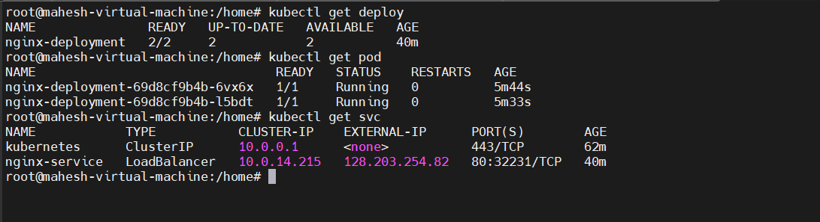

**# kubectl logs nginx-deployment-69d8cf9b4b-6vx6x**

/docker-entrypoint.sh: /docker-entrypoint.d/ is not empty, will attempt to perform configuration

/docker-entrypoint.sh: Looking for shell scripts in /docker-entrypoint.d/

/docker-entrypoint.sh: Launching /docker-entrypoint.d/10-listen-on-ipv6-by-default.sh

10-listen-on-ipv6-by-default.sh: info: Getting the checksum of /etc/nginx/conf.d/default.conf

10-listen-on-ipv6-by-default.sh: info: Enabled listen on IPv6 in /etc/nginx/conf.d/default.conf

/docker-entrypoint.sh: Sourcing /docker-entrypoint.d/15-local-resolvers.envsh

/docker-entrypoint.sh: Launching /docker-entrypoint.d/20-envsubst-on-templates.sh

/docker-entrypoint.sh: Launching /docker-entrypoint.d/30-tune-worker-processes.sh

/docker-entrypoint.sh: Configuration complete; ready for start up

2025/02/14 06:30:14 [notice] 1#1: using the "epoll" event method

2025/02/14 06:30:14 [notice] 1#1: nginx/1.27.4

2025/02/14 06:30:14 [notice] 1#1: built by gcc 12.2.0 (Debian 12.2.0-14)

2025/02/14 06:30:14 [notice] 1#1: OS: Linux 5.15.0-1079-azure

2025/02/14 06:30:14 [notice] 1#1: getrlimit(RLIMIT_NOFILE): 1048576:1048576

2025/02/14 06:30:14 [notice] 1#1: start worker processes

2025/02/14 06:30:14 [notice] 1#1: start worker process 28

2025/02/14 06:30:14 [notice] 1#1: start worker process 29

10.1.1.4 - - [14/Feb/2025:06:30:23 +0000] "GET / HTTP/1.1" 200 615 "-" "kube-probe/1.30" "-"

10.1.1.4 - - [14/Feb/2025:06:30:23 +0000] "GET / HTTP/1.1" 200 615 "-" "kube-probe/1.30" "-"

10.1.1.4 - - [14/Feb/2025:06:30:33 +0000] "GET / HTTP/1.1" 200 615 "-" "kube-probe/1.30" "-"

10.1.1.4 - - [14/Feb/2025:06:30:33 +0000] "GET / HTTP/1.1" 200 615 "-" "kube-probe/1.30" "-"

**# kubectl describe deploy nginx-deployment**

Name: nginx-deployment

Namespace: default

CreationTimestamp: Fri, 14 Feb 2025 11:25:19 +0530

Labels: <none>

Annotations: deployment.kubernetes.io/revision: 2

Selector: app=nginx

Replicas: 2 desired | 2 updated | 2 total | 2 available | 0 unavailable

StrategyType: RollingUpdate

MinReadySeconds: 0

RollingUpdateStrategy: 25% max unavailable, 25% max surge

Pod Template:

Labels: app=nginx

Containers:

nginx:

Image: nginx:latest

Port: 80/TCP

Host Port: 0/TCP

Liveness: http-get http://:80/ delay=5s timeout=1s period=10s #success=1 #failure=3

Readiness: http-get http://:80/ delay=5s timeout=1s period=10s #success=1 #failure=3

Environment: <none>

Mounts: <none>

Volumes: <none>

Conditions:

Type Status Reason

---- ------ ------

Available True MinimumReplicasAvailable

Progressing True NewReplicaSetAvailable

OldReplicaSets: nginx-deployment-576c6b7b6 (0/0 replicas created)

NewReplicaSet: nginx-deployment-69d8cf9b4b (2/2 replicas created)

Events:

Type Reason Age From Message

---- ------ ---- ---- -------

Normal ScalingReplicaSet 43m deployment-controller Scaled up replica set nginx-deployment-576c6b7b6 to 2

Normal ScalingReplicaSet 8m35s deployment-controller Scaled up replica set nginx-deployment-69d8cf9b4b to 1

Normal ScalingReplicaSet 8m24s deployment-controller Scaled down replica set nginx-deployment-576c6b7b6 to 1 from 2

Normal ScalingReplicaSet 8m24s deployment-controller Scaled up replica set nginx-deployment-69d8cf9b4b to 2 from 1

Normal ScalingReplicaSet 8m14s deployment-controller Scaled down replica set nginx-deployment-576c6b7b6 to 0 from 1

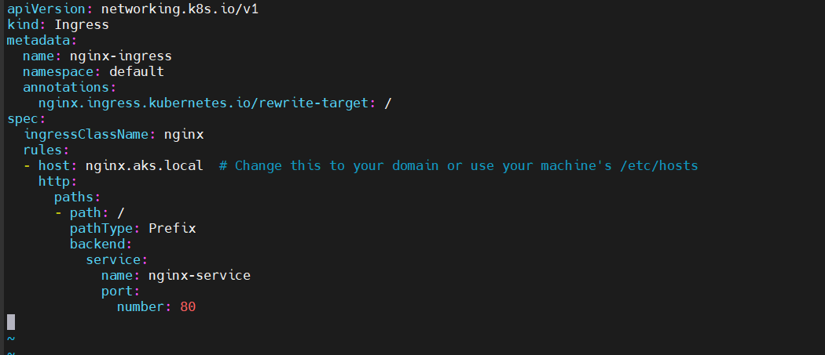

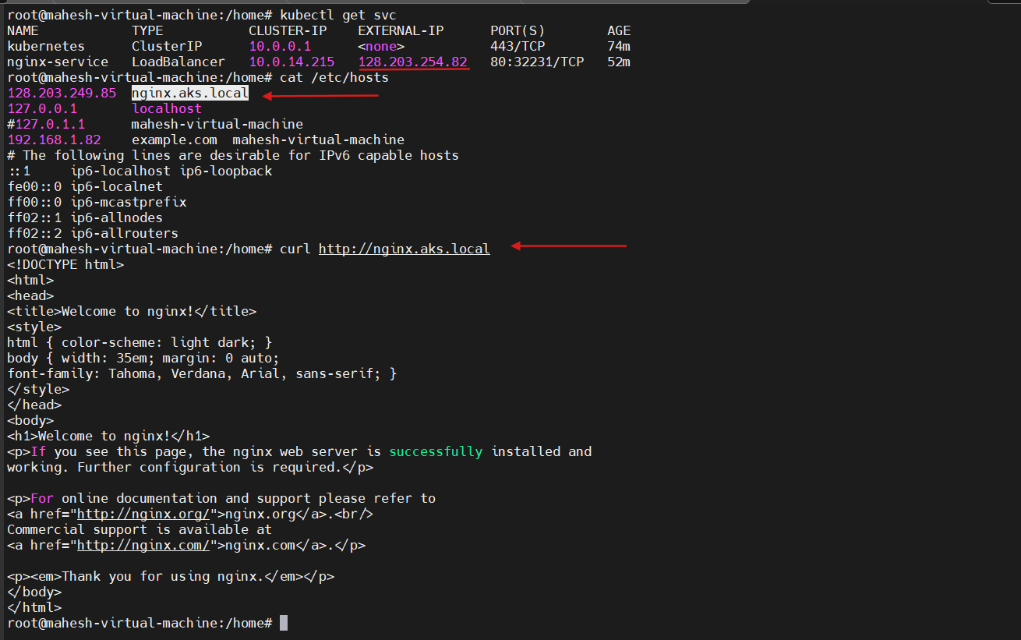

* **Screenshots:**

